Dashboard
- Performance Filters
  - Hide from drop-down
    - SearchType Image
    - SearchType Video
    - SearchType News
  - Countries
    - Keep only the top three countries, which will be taken from settings screen

GSC Traffic & Position Timeline
  - Option to enable/disable zoom on the chart in the settings
  - 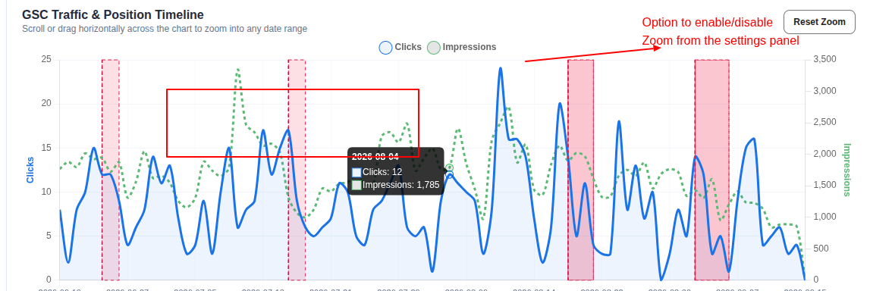
- Remove the Branded vs. Non-Branded Clicks chart
- Remove Keyword Position distribution chart
  - This will be added in a different screen later. Temporarily remove it.
- Queries Table
  - Remove
    - 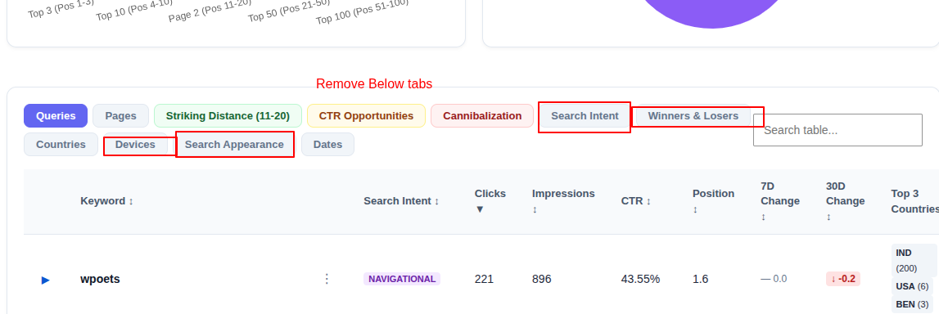
    - search appearance tab
    - Devices Tab
    - Winner and Loser Tab
    - Search Intent tab
  - Add Devices Column three: Mobile, Desktop, Tablet Which will show averages of three countries in total (which are selected from settings). Also Add horizontal scrollbar
  - 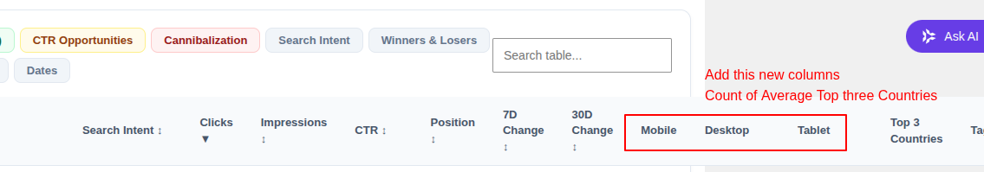
  - On expanding each keyword
    - For Clicks, Impressions and Pisiton show Total and respective Mobile, Desktop, and Tablet individual rows for each country
    - 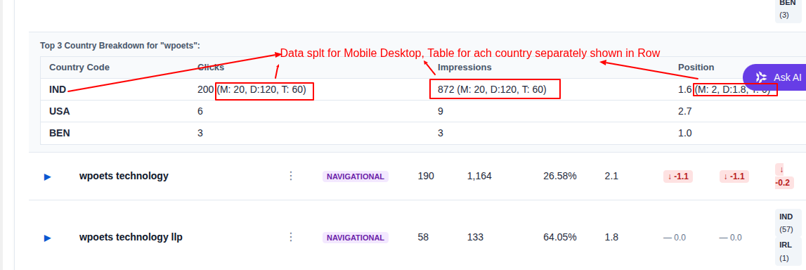
      - | Clicks | Impressions |
      - India | 100 (M: 20, D: 10: T: 80) | 2000 (M: 200, D: 1000: T : 1800)
      - US | 200 (M: 120, D: 20: T: 60) | 4000 (M: 2000, D: 2000: T : 0)
  - Remove Timeline Annotations & Algorithm Updates section
  - 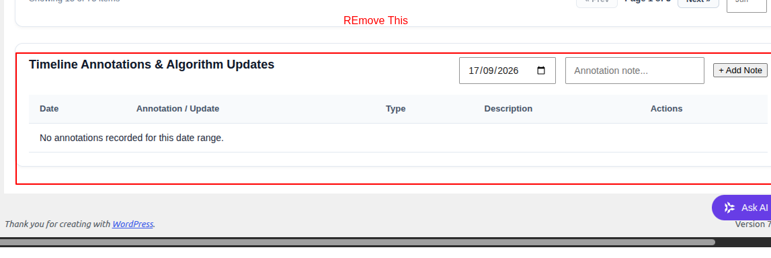

Remove menu,
- Compare URLs
- Links Intelligence & backlink graph
  - This will be added later using Backlinks Data integrated from
  - Google Search console
  - DataForSEO
  - Compare URLs
- Hide Menu Core Web Vitals
  - This will have lots of customization, and automation will be added in a separate phase

Create new submenu Rank Tracking (Through DataForSEO + GSC)
- In the settings, provide the option to add keywords for rank tracking
- We are not tracking all the keywords from GSC, only selected keywords. Keyword updates are weekly.
- Basic columns will be the same as the dashboard
  - USA
  - Keyword ▼
    - Expand
      - India (On expand only show india)
  - Search Intent ↕
  - GSC Clicks ↕
  - GSC Impressions ↕
  - GSC CTR ↕
  - GSC Position ↕
  - GSC 7D Change ↕
  - GSC 30D Change ↕
  - DFSEO Position
  - DFSEO Volume
  - DFSEO KD

Bugs
- Dashboard > Queries Tab
  - 7D Change ↕ 30D Change ↕
  - Data is not showing full only 75 items are shown
  - It should only show Data winit s not skippwed
- Skipped Keywords
  - Settings > Bulk Keywords Exclusion List
    - And Ranks stack > Skipped keywords should match
- GSC Synchronization Logs
  - It only shows one log even if manual sync is done
- Instead of sayi bg data sync just now show the date and difference count with previos date
  - For Eg., previous sync is 16/9/2026 and today is 18/9/2026 4pm show 2 days
  - For Eg., previous sync is 18/9/2026 12 pm and current time is 18/9/2026 4pm Show 4 hours ago
  - 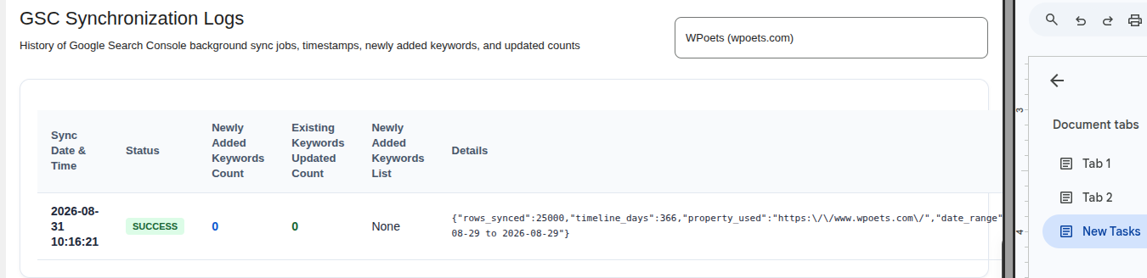

- Rankstack . keyword menu is showing only 135 queries

Ideas
- Kwyrods history timle screen
- Settings > Ass Skip Pattern and Words Custom

